The Territory of the People
Anglican Church

Territory Bulletin

22 August 2019
BISHOP’S MESSAGE:
And we know that in all things God works for the good of those who love him, who have been called according to his purpose. Romans 8:28
As I write this I am in the Yukon, and have just completed a one day retreat for Lesley Wheeler-Dame, who will be ordained on Saturday as the 12th Bishop of the Yukon.
On St. Bartholomew Day she will join a long list of faithful disciples which goes back to the first apostle named in our gospels. Apostles called by God to proclaim the gospel and carry out God’s mission on earth.
Soon we will select a new bishop to give leadership to the Territory. Yesterday’s retreat reminded me that God has already begun the process of preparing one to be your bishop – they have been called by God according to God’s purpose for our Territory. Our role now is to pray hard that we will be able to recognize the one who God has already called to serve us for the next chapter in our story as the Territory of the People.
Blessings,
+ Barbara
Almighty God,
giver of all good gifts,
look on your Church with grace,
and guide the minds of those
who shall choose a Bishop for this Territory,
that we may receive a faithful servant
who will care for your people
and support us in our ministries;
through Jesus Christ our Lord. Amen
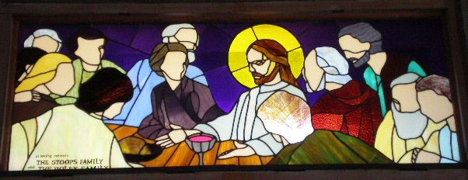
Photo courtesy of Margaret Mitchell
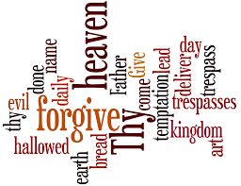
Prayers…
- We pray for the Rev Canon Isabel Healy Morrow as she continues her journey of recovery through dialysis and chemo treatments, giving thanks for all who support her.
    - We pray for the people of St. Timothy’s 100 Mile House, St. Peter’s Williams Lake and St. Luke’s Alexis Creek, as they continue their search for ordained leadership.

We pray for the Rev Canon Len Fraser as he mourns the death of his wife Sheila, we pray for Len and Sheila’s families.

We pray for Archbishop Linda Nicholls elected in July as the 14th Primate of the Anglican Church of Canada, as she leads the church in discerning and pursuing the mission of God.
- We pray for Lesley Wheeler-Dame, as she prepares for ordination as the 12th Bishop of the Yukon
- We pray for new vocations for leadership in the church, especially for the Territory of the People.
- We pray for Bishop Barbara during this time of transition prior to her retirement in December.
Letter of Thanks
I would like to thank everyone for all the love and support Sheila and I received while Sheila was in the hospital. The journey leading to Sheila’s death, though it was short, seemed incredibly long for Sheila’s family and myself. Though I still feel in total shock over Sheila’s death, I am so grateful for all the love and support I have received from everyone.
The parishes of Grace and St John’s have been so supportive I cannot thank them enough. I am so grateful to St Michael and All Angels for their hospitality and generosity in the service of celebration of Sheila’s life.
Sheila’s death has impacted many in the community and beyond; without the support from Bishop Barbara, Rev Peter Zimmer and many others I could not possibly get through this alone. I am truly blessed to live in such a loving and caring community.
Sheila’s family and I are so grateful for all the love and support we have received through this difficult time. We hold those memories of Sheila in our hearts, and we will always treasure the abundance of grace we have received.
Len Fraser
Territory News
The Northern Deanery’s Treasurers and Wardens Workshop - will be held on Saturday September 14th, at St. Peter’s Anglican Church, Williams Lake. Registration at 9:30 – 10:00am
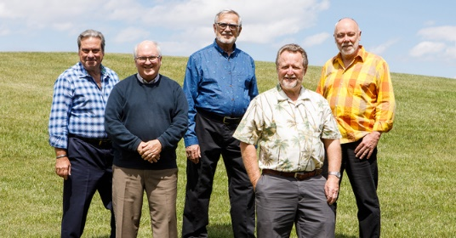
Common Cup in Concert – Wednesday September 18th, at St. Paul’s Cathedral Kamloops, 7pm – tickets at the door or from the Cathedral office - $20/per person (under 12 free)

Electoral Committee News August 2019
The Nominations Committee oversees all aspects of seeking and accepting nominations, making sure the candidates are properly notified and vetted and ensuring delegates to the Electoral Assembly have accurate information about all the candidates well ahead of the Assembly.
A pared-down Nominations Committee consisting of Melissa Green, Ken Ponsford, Brenda Munroe and Dwight Oatway has completed the bulk of its work.
Nominations have been received and Request for Information packages have been sent to the nominees who met the initial criteria. Responses from nominees are to be received by the Nominations Committee by midnight, August 23. Members of the Nominations Committee will review the packages for completeness and will conduct interviews with 3 referees for each nominee to ensure all nominees are qualified to stand as candidates for our Episcopal Election.
The names of qualified candidates will be shared with the Electoral Committee and the BC and Yukon House of Bishops. Once the work of the committee is complete the Electoral Committee will issue a list of qualified candidates for the electoral ballot along with the Candidate Information Packages. This information will be posted on the Territory of the People website and sent to Assembly Delegates on September 5.
Questions about the work of the Electoral Committee or the Nominations Committee can be forwarded to Melissa Green at territoryelection@gmail.com
Submitted by Ken Ponsford
Member-at-Large, Electoral Committee

OTHER NEWS
Anglican Foundation of Canada – a July publication titled “Generosity Changes Everything” includes an article by Bishop Barbara regarding recent grants awarded to the Territory of the People. Check out the AFC website here for more news and interesting information about the work of the Foundation.

Kootenay School of Ministry – There’s still time to register for the Fall sessions!
P101 Being Anglican - Instructor: Dr. David Neelands
Dates: Saturdays Sept 14 – Nov. 9 10:00 am12:00 noon using ZOOM videoconferencing
Cost: $99 to audit / $250 for credit
This is an excellent course for those who want to understand “the large and beautiful family” who call themselves Anglicans. Taught by a highly respected instructor who loves to teach.
FREE drop-in introductory Zoom session Saturday, Sept. 7, 2019 from 10:00-10:30 am to meet the instructor, talk about the course, and try the ZOOM platform https://zoom.us/j/122776193
P102 - Evangelism Remixed Instructor: Dr. Judy Paulsen
Dates: Tuesdays Sept. 10 – Dec. 3 11:00 am – 2:00 pm using ZOOM videoconferencing
Cost: $320 audit / $520 for credit (Wycliffe price)
Judy is the Director of the Institute of Evangelism at Wycliffe College. Judy’s parents were Anglican missionaries, and she spent her early childhood years in northwest India.
Click here to go to the KSM webpages

Prayer
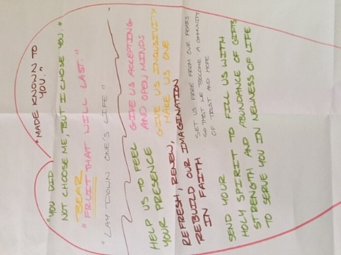
This prayer was one of many which were formed during the table exercise of the Heartbeat of the Church led by Archbishop Fred Hiltz. The Archbishop used this prayer during the final Eucharist of Assembly 2019.
Loving and faithful God,
You chose us, and we are made known to you
through your well beloved Son Jesus Christ
who laid down his life for us.
Help us to feel your presence,
Give us accepting and open minds,
Give us inclusivity and make us one.
Refresh, renew, and rebuild our imagination in faith.
Set us free from our fears so we may become
a community of trust and hope.
Send your Holy Spirit to fill us with strength
and abundance of gifts,
So we may serve you in newness of life
and bear fruit that will last. Amen

HANDY LINKS:
- Book of Alternative Services: click here
- Common Praise online: click here
- Territory of the People website: click here
- 201p Calendar of Intercessions Prayer Cycle – July to September: click here
- Pilgrim Paths: labyrinth prayer walks accompanying the church year of prayer, feasts and celebrations. Volumes One and Two in pdf format. More information here
- Employee Assistance Program (Lifeworks). Click here
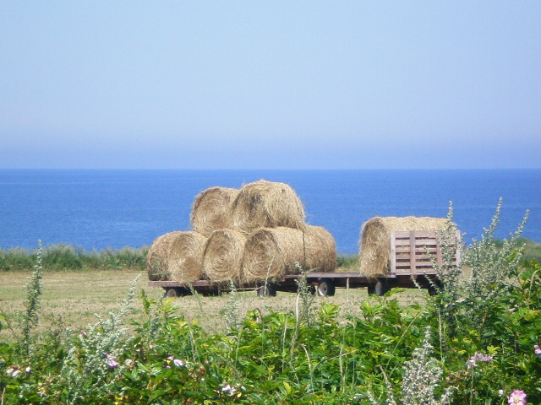
Make hay while the sun shines,
Summer’s almost over…
Photo taken on Prince Edward Island, August 2007 by Margaret Mitchell

BISHOP’S SCHEDULE AND IMPORTANT DATES AND DEADLINES

August 19-26 Ordination of new Bishop – Diocese of Yukon, Whitehorse  Meeting of the BCY House of Bishops  Sept 1 Deadline Anglican Foundation Grants  Sep 8 St. Mary the Virgin/St. Andrew, Lillooet Parish visit  Sept 15-20 National House of Bishops, Niagara Falls  Sept 21-22 Indigenous House of Bishops, Toronto  Sep 22 Cariboo Group – Grace on the Hill, Toronto  Sept 22-25 Council of the North, Toronto  Sept 26 Administration Committee,  Zoom 7pm  Sept 28 Electoral Assembly, Ashcroft  Sept 29 Robson Valley Parish Visit | Oct 15 Grants Deadlines:  Territory Parish Grants, Rufus Gibbs  Oct 17-21 Cariboo Deanery visit  Oct 19 Cariboo Deanery Regional Meeting  Oct 21-24 Clergy Conference, Sorrento Centre  Oct 27 St. Michael’s Merritt Parish visit  Nov 3 Scw’exmx Parish visit  Nov 10 Lytton Parish visit  Nov 17 St. Paul’s, Kamloops Parish visit  Nov 22-23 Coordinating Council – The Shrine, Cache Creek  Nov 24 St. Michael’s Merritt Parish visit  Dec 1-21 Vacation time  Dec 22 St. Michael’s Merritt Parish visit  Dec 24 4pm & 7pm St. Paul’s Christmas services  Dec 24 10 pm St. George’s Kamloops Christmas Service  Dec 31 Happy New Year!

2020 Holidays and Observances
Jan 1 | New Year’s Day |  | Jun 21 | Father’s Day
Jan 6 | Epiphany |  | Jun 21 | National Indigenous Peoples Day
Feb 2 | Groundhog Day |  | July 1 | Canada Day
Feb 14 | Valentine’s Day |  | Aug 3 | Civic Holiday
Feb 17 | Family Day |  | Sep 7 | Labour Day
Mar 9 | Commonwealth Day |  | Oct 12 | Thanksgiving Day
Mar 17 | St. Patrick’s Day |  | Oct 31 | Hallowe’en
Apr 10 | Good Friday |  | Nov 11 | Remembrance Day
Apr 12 | Easter Sunday |  | Dec 24 | Christmas Eve
Apr 13 | Easter Monday |  | Dec 25 | Christmas Day
May 10 | Mother’s Day |  | Dec 26 | Boxing Day
May 18 | Victoria Day |  | Dec 31 | New Year’s Eve

